WHO’S WHO?
Men of the Scientific Revolution
Directions: Read the "Who's Who?" profile sheets and chart the information.

Nationality/ Field/Area of Discovery/ Impact on Science
Scientist Place of Science Theory/Laws? and Society
Birth Beliefs
Copernicus

Galileo

Kepler

Harvey

Newton

Scientific Revolution: Who's Who Profile Sheet

William Harvey (1578-1657) was an English doctor who was fascinated by the human body. While he grew up in England, he studied medicine in Italy. When he returned to England, William Harvey became the physician to kings and queens. But, he is most famous for solving the riddle of how blood moves through the body. Prior to William Harvey, most physicians thought that blood started in the liver instead of the heart. Instead, he discovered that the heart was the beginning point for the circulation of blood. Not only that, William Harvey found that blood makes a full circuit through the body.
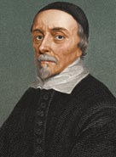

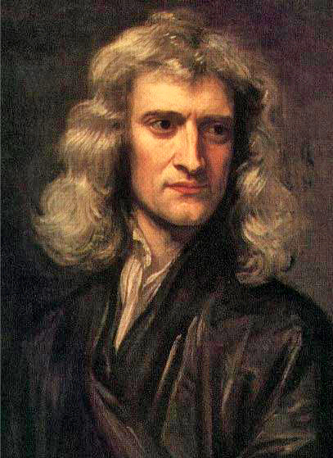
Isaac Newton (1642-1727) was an English
physicist, mathematician, astronomer, and
philosopher. He stated the three universal "laws
of motion" that were not improved upon for more
than two hundred years. He used the Latin word
gravitas (weight) for the force that would become
known as gravity, and defined the law of
universal gravitation. This law was developed
after watching an apple fall while in his orchard.
In 1703, Newton became president of the Royal
Society of London. He is considered one of
history's greatest scientists, ranking alongside
such figures as Einstein and Gauss.

Newton's calculations changed the way people understood the universe. No one had been able to
explain why the planets stayed in their orbits.
What held them up? Less than 50 years before Isaac Newton was born it was
thought that the planets were held in place by an invisible shield. Isaac proved that
they were held in place by the sun's gravity. He also showed that the force of
gravity was affected by distance and by mass. He was not the first to understand
that the orbit of a planet was not circular, but more elongated, like an oval. What
he did was explain how it worked.

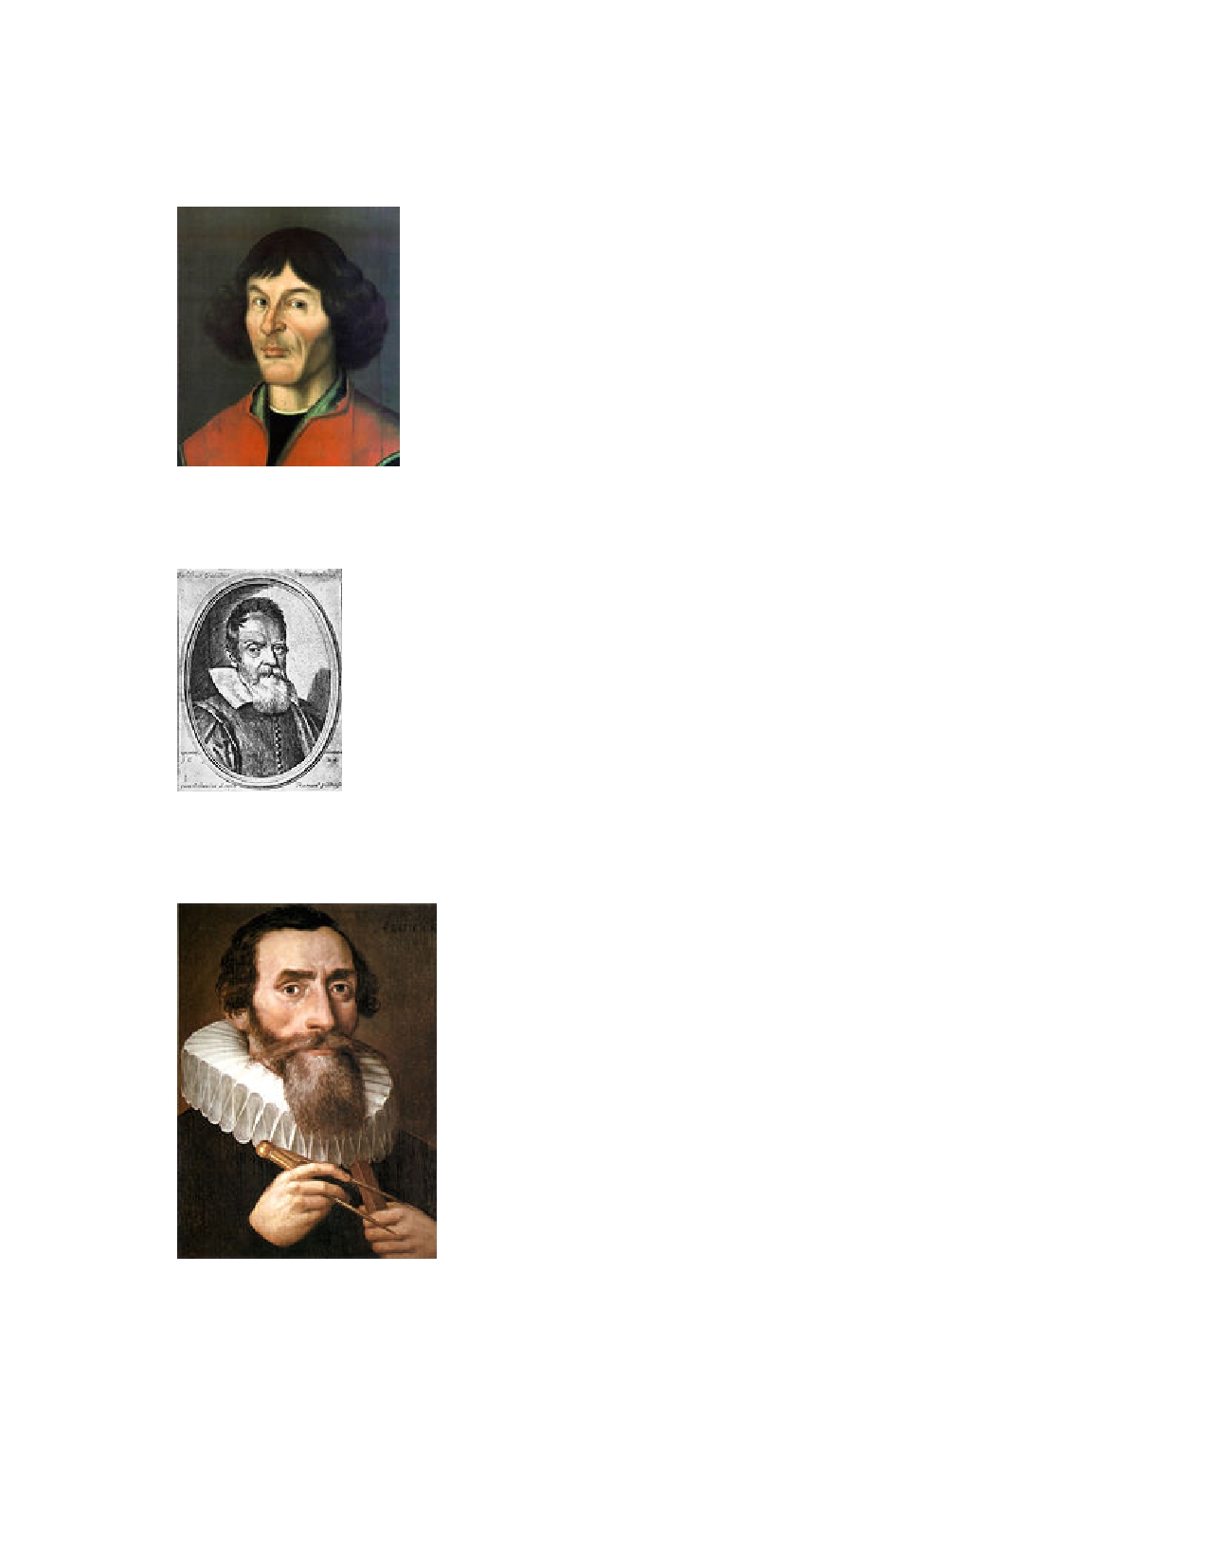
Scientific Revolution: Who’s Who Profile Sheet

Nicholas Copernicus (1473-1543) was a Polish
astronomer, mathematician, and economist who developed
the heliocentric (sun centered) theory of the solar system.
His theory about the sun as the center of the solar system
overturned the geocentric theory (Earth as the center of
the solar system). This theory was the fundamental
starting point for modern astronomy and modern science
itself. His work affected many other aspects of human life
as well, opening the door to young astronomers everywhere
to challenge the facts and never take anything at face value.

Galileo Galilei (1564-1642) was a Tuscan (Italian) astronomer,
philosopher, and physicist who was an important part of the
Scientific Revolution. His achievements include improving the
telescope, making important astronomical observations, and
making the first law of motion. He fully supported the teachings
of Copernicus. He is often called the "father of modern
astronomy", the "father of modern physics", and the "father of
science". Because of his beliefs, he was branded a heretic by the
Roman Catholic Church and imprisoned for life.

Johannes Kepler (1571-1630) was born in southwest Germany. He became a professor of mathematics at a
Protestant seminary in Austria where he pursued the
study of astronomy and astrology. In 1609, his work
called the Astronomia Nova ("New Astronomy")
appeared containing three laws of planetary motion.
One of these states that the planets move in elliptical
orbits with the Sun at one focus. Another law stated that
planets sweep out equal areas in equal times. In 1610,
he heard about Galileo's discoveries with the spyglass
and wrote letters (tracts) which were an enormous
support to Galileo, whose discoveries were doubted and
denied by the Catholic Church. Kepler also suffered
persecution at the hands of the Church. Kepler is
considered to be the "founder of physical astronomy".

